The Mississippi Queen
by Walter Hodel, Goldsieber 1997
An exciting steamboat race for 3-5 players aged 10 and up.
In competition for the title of "Mississippi Queen" for the captains of the fastest paddle-wheeler on the Mississippi deliver a breathtaking race. In order to make the game easier to learn, we've divided the rules into two parts. First there are the rules for a short introductory game, the "Mississippi Queen driving school". This is intended for those who play “Mississippi Queen” for the first time. Here they will learn how to move the paddle-wheelers and how to create the course of the river.
Once you have played this introductory version, you will be ready for the proper race. This introduces passengers into the game and makes the game substantially more tactical. Please read the section with the passenger game after the short introductory game.
Contents
- 12 River tiles (of which one is the starting place)
- 1 Landing platform
- 1 Measuring stick (any short ruler will do as replacement)
- 5 Paddle-wheelers
- 10 Paddle wheels
- 16 Passengers
- 1 Direction die
Mississippi Queen driving school
Preparations for the introductory game
- Each player receives a Mississippi paddle-wheeler and two paddle wheels (one with red numbers and one with black numbers).
- The wheel with the red numbers is the speed wheel and is placed in the left-hand compartment of the steamboat. At the beginning it is turned on number “1”.
- The wheel with the black numbers is the coal wheel and is placed in the right-hand compartment of the steamboat. At the beginning it is turned on number “6”.
- The river tile with starting place, that shows the fields from 1 to 5, is picked out and placed in the middle of the table.
- Draw any 3 random river tiles out of the remaining eleven and put them aside as reserves. The remaining river tiles will not be required in the introductory game.
- Place the landing platform face-up under the pile of the three reserve river tiles.
- Have the direction die to hand.
- The passengers and the measuring stick will not be needed in this version. They remain in the box.
Starting position
Turn over the topmost river tile of the reserve pile and attach it to the middle cusp of the start tile in a straight ahead position (Like in a puzzle - see picture below)
The youngest player starts. He places his paddle-wheeler on starting space number “1”. The others follow in clockwise order and occupy the following spaces “2”, then “3” etc. When placing the paddle-wheelers, the players may position them facing in any direction. The race can begin.
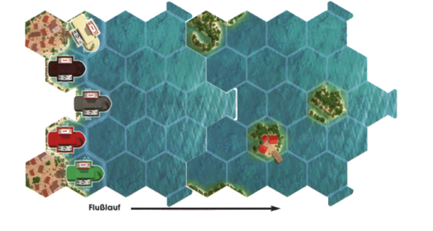
The course of the game
Speed and coal reserves
The player who has his paddle-wheeler on space “1” starts, the others follow in clockwise direction. In his turn, the player may, before moving, regulate the speed on the speed wheel (red numbers). He may keep the speed or raise or lower it by one point for free. If the player wants to change his speed by more than one point, he will require coals - for each additional speed point (lowered or raised) he will need one coal point.
Examples:
- The speed is increased from “2” to “4”. This costs one coal point.
- The speed is reduced from “6” to “3”. This costs two coal points.
The changed coal reserves are immediately adjusted on the coal wheel (black numbers). Should the last coal point be used, the coal wheel is removed from the compartment and returned into the box. If later on, the paddle-wheeler without coal wheel would require another coal point, it is removed from the river and that player drops out of the game. He is disqualified. In this short introductory game this will rarely happen that somebody drops out.

Moving and turning
- The set number on the speed wheel indicates the number of spaces that a paddle-wheeler must move i.e. with a set “4” the paddle-wheeler moves 4 spaces. For each speed point the paddle-wheeler must move one space in the direction of travel, with the bow to the fore. Reversing, i.e. going backwards is not allowed.
- Paddle-wheelers normally move over unoccupied water spaces. (Exception: see "Pushing other steamboats").
- They may not move onto or over islands, or off the edge of a river tile.
- Per turn, each player can make one turn of 60 degrees in either direction for free.
- Each additional 60 degree turn costs one coal point. The coal wheel is immediately adjusted by one point accordingly.
- A player may turn his paddle-wheeler before, during or after the move.
Laying out the river
Whenever a paddle-wheeler reaches a river tile, on which there is no other paddle-wheeler yet, the player must attach another river tile. To do that, the player throws the direction die. The resulting arrow on the die tells him whether to add the next river tile on to the left, middle, or right cusp of the tile he currently occupies. He then takes the topmost river tile from the reserve pile and fits it to the thrown direction. This however, only happens when he has completely finished his movement.
Example: Even though the paddle-wheeler only moves 2 spaces, it must make 3 turns.
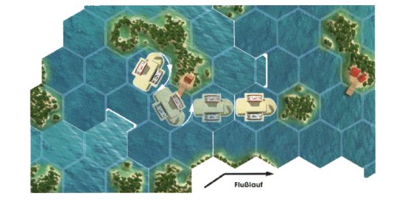

Example: The player is coming from river tile A and moves onto the unoccupied new river tile B. After he has fully completed his movement on B, he throws the direction die. The next river tile C must be fitted to the left connection cusp, according to the arrow on the die.
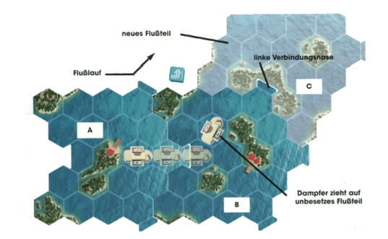
- If, due to its set speed, a paddle-wheeler is forced to run aground or go off the river tile, it must slow down or exercise additional turns.
- The first river tile is fitted as soon as a paddle-wheeler exits from the starting tile.
- Important: river tiles cannot be laid so as to form a continuous loop. If this were the case, the die must be thrown again.
- As soon as the last river tile has been fully vacated, it can be removed from the table and put back into the box.
Hint: It’s best if you arrange the displayed river tiles in a way that the course of the river is always in the middle of the table.
Pushing other steamboats
- Normally, the paddle-wheelers only move across empty water spaces. It is however, allowed to push other paddle-wheelers that stand in your way to one side.
- Each push costs the pushing player that wants to push another paddle-wheeler, one movement space. With this movement point, the other paddle-wheeler is moved to an unoccupied adjacent space. So the pushing player may move his paddle-wheeler only one space less than indicated on his speed wheel.
- If a player was to push even two paddle-wheelers, then his paddle-wheeler would even move two points less than the indicated speed.

- A paddle-wheeler cannot be pushed onto spaces with an island. Similarly, the spaces over which the pushing player has just moved this turn, including the one from which he pushed the opponent, are not allowed. If it is thereby impossible to push another paddle-wheeler, the push may not be executed.
- The player whose paddle-wheeler was pushed may immediately point his steamboat in whichever direction he chooses.
Example: Red wants to push beige. Red has a current speed of “4”. He moves onto the space of beige (first point), pushes beige on the adjacent space “A” (second point) and moves straight ahead two spaces (movement point three and four).Beige may now point his paddle-wheeler in any direction. Instead of space “A”, beige could only have been pushed onto the spaces marked with an “X”.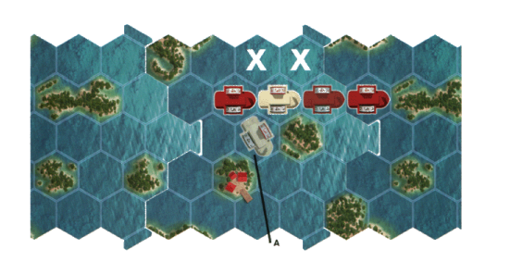
- Should the player have enough movement points to reach the space occupied by another paddle-wheeler, but not enough spare points to push aside, he cannot move onto this space. He must still fully utilize his movement points and must move onto another space instead.
- Should a paddle-wheeler be pushed onto a new unoccupied river tile, the player fits another river tile as previously described. This may only happen once he has completed the direction of his steamboat.
End of the Race
The player, who places the last river tile, immediately rolls again to determine the location of the landing platform. As shown in the diagram below, there are three hexes which are points of entry to this platform. These hexes connect to three spaces of the last laid river tile. They represent the finishing spaces.
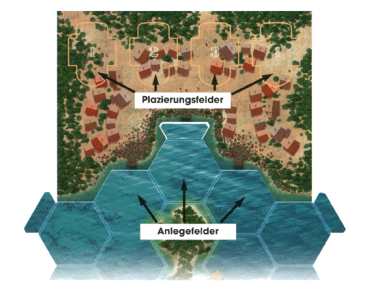
The paddle-wheeler that first reaches one of these finishing spaces wins. Remaining movement points may be forfeited.
If there happens to be island occupying one of the finishing spaces, then there can only be two entry spaces. The winner places his paddle-wheeler on position number “1” of the finishing spaces. The other players continue to play for the remaining positions.
These are all the rules for the short introductory game. Now, you can immediately begin with the game. Afterwards, read the additional rules for full race with passengers.
Structure of a turn movement (Short version)
- Keep the set speed or change it (possible reduction of coal reserves)
- Move the paddle-wheeler as many spaces forward as indicated by the speed wheel. (A single 60 Degree turn is free; any further turn causes reduction of coal reserves.)
  - If the paddle-wheeler moves onto a space occupied by another paddle-wheeler, it will be pushed off.
  - If the paddle-wheeler moves onto a new unoccupied river tile: the turn must be completed before the direction die is thrown to determine on which cusp the next tile is laid.

Additional rules for the full game:
The passenger game
When you have played the introductory game once, you will know how to maneuver your paddle-wheeler. The full game introduces the element of the passengers. Once again it is the aim to reach the landing platform first. Now however, you must collect two passengers along the way in order to win. To make the race more exciting, the play order is no longer in clockwise direction. Instead, once all players have played once, the leading paddle-wheeler will move first, followed by the others in the order of their positions.
All previously described rules are still valid, with the introduction of the following additions or modifications:
Game preparations
- All 11 river tiles are now put aside as a face down reserve pile.
- The measuring stick is put beside to hand.
- The paddle-wheelers are placed on the starting tile as described above and the first river tile is fitted.
- The passenger figures are places beside the face down reserve pile of river tiles, in the following denomination:
  - With 3 players - 8 passengers
  - With 4 players - 12 passengers
  - With 5 players - 16 passengers
Unused figures remain in the box.
Placing passengers at stations
As soon as a river tile is fitted that contains an island with a station (one or two buildings with a platform), passengers are placed on that station, as per the following denomination:
- With 3 players - 1 passenger per station
- With 5 players - 2 passengers per station
- With 4 players - 1 passenger on red stations and 2 passengers on brown stations
Should there already be a river tile with buildings at the initial set-up; passengers have to be added here as well accordingly.

Collecting passengers
In order to collect a passenger from a station, the paddle-wheeler must be at boarding platform. The paddle-wheeler must move to complete halt at the boarding platform. The movement must end on that space.
- The speed indicated on the speed wheel must be “1”. The player may collect one passenger and place him in front of him.
- If a player has already collected 2 passengers, he cannot collect any more.
- No player may collect 2 passengers from the same island.
Hint: There are enough passengers for all. In the five player game, only 10 of the 16 passengers are required. There is no need to fight over the passengers on the first island sighted.
Example: (see page 9) Red wants to collect a passenger. He reduces speed to “2” and moves two spaces. In his next move he can reduce his speed further to come to a complete halt at the boarding platform with a speed of “1”.
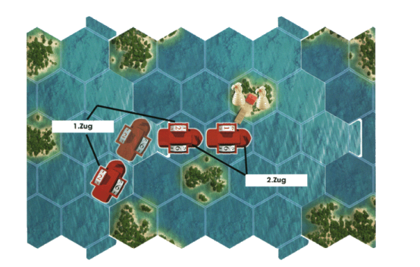
- Should a player be pushed to a boarding platform and his speed wheel is displaying the speed of “1”, he may collect a passenger from this platform, unless of course he has already collected a passenger from this same station.
- When a river tile is removed from the table because all steam boats have vacated it, any remaining passengers there are returned to the box.

Order of movement (as opposed to introductory game)
- The paddle-wheeler that is on the furthest ahead river tile goes first, then the one that is on second position etc.
- If 2 paddle-wheelers are on the same level, the one displaying the greater speed moves first.
- If the speed is also on level, the one with the greater coal reserves goes first. If it is still not possible to determine a concrete movement order, the paddle-wheeler further to the right moves first.

Help to determine the position
- If there are two paddle-wheelers on the same river tile and it is not obvious “at first glance”, which is in front, it is helpful to use the measuring stick.
- The measuring stick will be put on the river tile in question. As shown in the diagram below, the stick is placed on the connecting cusp, where the river is going.
- Then the measuring stick is moved backwards until it reaches the space of one of the unclear paddle-wheelers.
- The paddle-wheelers don’t have to be facing in moving direction. The direction is irrelevant. Only the space on which they stand is important to determine the order of movement.
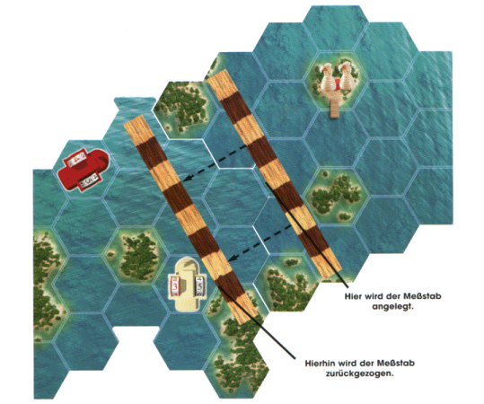
Example: First, the grey paddle-wheeler moves. With the help of the measuring stick it becomes obvious, that both red and beige are on the same level. Now it is relevant, which has set the higher speed. Since the speed is the same with both paddle-wheelers, the higher coal reserves matter. Since these are the same as well, it is “right before left”. Beige moves before red. Then green moves, because it is on a river tile ahead of brown.
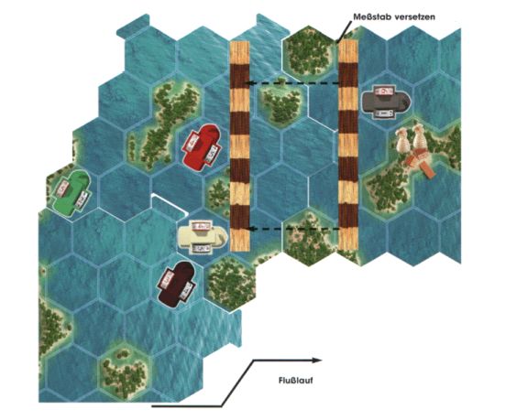
The end of the game
Even with the passenger game, the winner is who first lands at one of the finishing spaces, provided he has previously picked up two passengers.
Important: In contrast to the introductory game, the paddle-wheeler entering the finishing space must have its speed set on “1” (as in collecting a passenger). Should a paddle-wheeler be pushed on finishing space, while having the speed of “1”, it is considered as finished.

